Amazon Interview Worksheet
OWNERSHIP

Definition and Indicators

Ownership: Leaders are owners. They think long term and don’t sacrifice long-term value for short-term results. They act on behalf of the entire company, beyond just their own team. They never say “that’s not my job”.
What this looks like in Practice
As a people manager do you… | As an individual contributor do you…
- Create a vision for your team that aligns with the customer experience?  - Foster an environment of autonomy where an employee prioritize and make decisions?  - Think about the impact of your decisions on other teams, sites and the customer over time?  - Coach and mentor your team to understand the big picture, how their role supports the overall objectives of Amazon, and how it ties to others? | - Ask questions?  - Consider future outcomes (scalable, long-term value, etc.)?  - Give feedback – coach and develop others (peers, associates, manager)?  - Speak up in meetings – question, challenge respectfully?  - Understand your role and relationship with other roles?  - Understand the impact of your work on others?  - Partner with peers across the network?

Ownership - Suggested Behavioral Interview Questions
For each question you choose, use a separate STAR Worksheet
Questions for (Manager) in parentheses

- Tell me about a time when you took on something significant outside your area of responsibility. Why was it important? What was the outcome?
- Give me an example of a time when you didn't think you were going to meet the commitments you promised. How did you identify the risk and communicate it to stakeholders? What was the outcome?
- Tell me about a time you made a hard decision to sacrifice short term gain for a longer term goal.
- Give an example of when you saw a peer struggling and decided to step in and help. What was the situation and what actions did you take? What was the outcome?
- What steps do you take to ensure projects you complete get transitioned effectively to new owners? Give an example where you elected to re-engage on a project that you had already transitioned to someone else. What was the situation and why did you feel it was important to re-engage?
- How do you ensure your team stays connected to the company vision and the bigger picture? Give an example of when you felt a team or individual goal was in conflict with the company vision. What did you do? (Manager)
- Tell me about an initiative you undertook because you saw that it could benefit the whole company or your customers, but wasn’t within any group’s individual responsibility so nothing was being done. (Manager)

STAR WORKSHEET

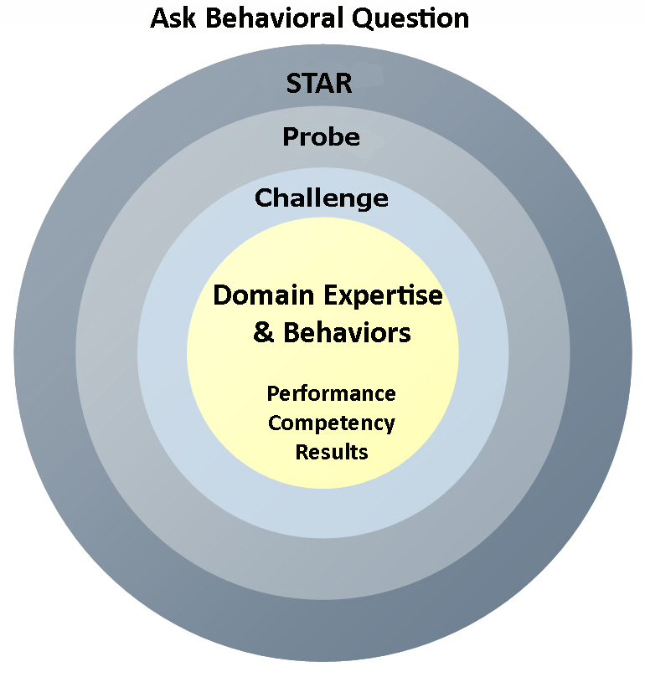
Your Behavioral Question:___________________________________________________________________Leadership Principle:_________________

- Choose behavioral question that provoke specific examples or stories for your assigned Leadership Principle(s).
- Process the example using STAR. Stories have beginnings (Situation/Task), middles (Actions) and ends (Results).
- Once you have established the story, PROBE to dive deeper on your assigned competency (Leadership Principle), get clarity or pursue a concern.
- If appropriate, CHALLENGE the candidate’s statements, decisions or thought process.
S  T | SITUATION/TASK - Describe the situation/task you faced and the context of the story  Answers the questions: where did this occur, when did it happen, why is it important?  Probing Questions:  - Why is this important? What was the goal?  - What was the initial scope of the project? What were the challenges?  - What were the risks and potential consequences if nothing happened?  Challenge Questions:  - Why did you choose this story to illustrate a xyz accomplishment?  - What other stories can you think of that demonstrate.. xyz?  - Could you come up with an example that is more recent? | Notes
A | ACTION - What actions did you take?  Answers the questions: what did you personally own, how did you do it, who else was involved?  Probing Questions:  - Deep probe functional expertise and/or assigned core competency.  - Were you the key driver or project owner?  - What was your biggest contribution? What unique value did you bring?  - What were the most significant obstacles you faced? How did you overcome them?  Challenge Questions:  - What did you do specifically versus the team?  - How did you set priorities…deal with xyz problem… or get manager buy-in?  - What decisions did you challenge? Why? How did you influence the right outcome?
R | RESULTS - How did you measure success for this project? What results did you achieve?  $ Cost savings, revenue generation  # Quantify to understand volume, size, scale  % Percentage change, year over year improvements  Time to market, implementation time, time savings  Impact on the customer, the team  δ Quality improvements  Probing Questions:  - Why did you choose to focus on these results? What other results were important?  - You mentioned revenue, what percentage change is that year over year?  - What trade-offs did you have to make to achieve this? (quality, cost, time)  - I’m concerned about… (the time it took, the volume, the customer impact), tell me more…  Challenge Questions:  - What were the lessons learned? What would you have done differently?  - How would you implement this at Amazon?  - How did these results compare to your actual goals? (refer back to goal stated in Situation)

